VUID Tool Box Documentation

Phil Shinn
April 15, 2010

Table of Contents

List of Figures 2
Introduction 3
Introduction 3
Requirements 3
Overview 3
Users 5
Getting Started 6
VUIStencil.vss 7
Developing a Call Flow 8
Exporting The Prompt List 11
Comparing Prompt Lists 12
Exporting the Grammar List 13
Generating Use Cases with MakeScripts.py 14

List of Figures

Figure 1 VUID Tool Box Functional Diagram 4
Figure 2 Visio Startup 6
Figure 3 The VUI Stencil Symbols 7
Figure 4 Start Tab of myBank.vsd 8
Figure 5 Initial Grammar Custom Properties 9
Figure 6 Filled-in Grammar Customer Properties 9
Figure 7 Start Tab 10
Figure 8 Exporting the Prompt List 11
Figure 9 Exported Prompt List in Excel 11
Figure 10 Comparing Prompt Lists 12
Figure 11 Output of Compared Prompt Lists 13
Figure 12 Exported Grammar List Excel File 13
Figure 13 Source Use Case 1 14
Figure 14 Running MakeScripts.py 15
Figure 15 Use case 1 output. 16

Introduction

This document describes the Voice User Interface Designer (VUID) Toolbox, a collection of tools that supports designing and maintaining a voice user interface (VUI). The tools do not generate code, but rather partially automate the design. Think of them as a sort of VUI CAD system.

The code was written by Phil Shinn and Matt Shomphe, and placed into the public domain in 2007. Our goal was to make life easier by helping to set up a uniform standard markup language for VUI designs. Since then, a number of organizations have adopted the toolkit for their own use.

The code is free, as in free beer. If you would like support, or would like to schedule a training session, please contact Phil Shinn at phil.shinn@gmail.com or call +1 (646) 736 -2377.

The code is licensed under the GNU General Public License version 3 (GNU GPLv3), which is described here: http://www.gnu.org/licenses/quick-guide-gplv3.html. These are the terms: “This program is free software: you can redistribute it and/or modify it under the terms of the GNU General Public License as published by the Free Software Foundation, either version 3 of the License, or (at your option) any later version. This program is distributed in the hope that it will be useful, but WITHOUT ANY WARRANTY; without even the implied warranty of MERCHANTABILITY or FITNESS FOR A PARTICULAR PURPOSE. See the GNU General Public License for more details.” You should have received a copy of the GNU General Public License along with this program, in the file gpl-3.0-standalone.html. If not, see <http://www.gnu.org/licenses/>.

Requirements

- Microsoft XP or Windows 7
- Visio 2003 or 2007 or 2010 Professional
- VUIStencil.vss and other tools distributed with this package.
- Python 2.4 (or better): Download & install this from www.python.org.
- Win32 Python extensions: Download & install this from: http://sourceforge.net/projects/pywin32/ (or find links from http://www.python.org/download/download_windows.html). NB – You must install Python before installing the Python Win32 extensions.
- The VUID code – can be downloaded from https://sites.google.com/site/ivrdesigngroup/vuid-toolkit

Overview

In a nutshell, you use Visio and the symbols in VUIStencil.vss to create a graphical state diagram representation of an application. You then use two custom Visual Basic macros to extract from the Visio diagram two Excel spread sheets:

- Prompt list, which has prompt file names and corresponding prompt text.
- Grammar list, which has a list of grammar names.

You then generate a set of Excel sheets containing source use cases. These cases show the major traversals of the state diagram. The source use cases actually don’t contain what the system says, but rather, they contain the file names of the system prompts, followed by the actual text of what the user says (or presses, or doesn’t say in the case of a time out).

After you’ve generated the source use cases, you use the Python script MakeScripts.py. It takes as input the prompt list and the list of use cases, and generates as output a single document that contains all the use cases with the prompt text substituted for the prompt names. The advantage of this is you can change the prompt text at will and regenerate final use cases automatically.

The following diagram shows these components.

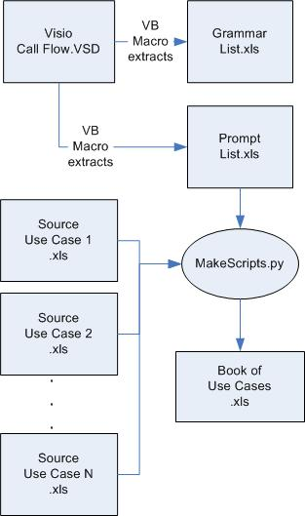

Figure 1 VUID Tool Box Functional Diagram

Users

There are a couple of different users of these design artifacts in addition to the VUI designer, who typically uses the tools to iteratively evolve the design. The fact that many of the participants in the development of a speech application can use the same document greatly simplifies document tracking and communication.

Business owners like to see use cases since these are easy to read and understand, whereas trying to parse through a state diagram can be difficult. In our experience, getting business to participate in WOZ design reviews and eventually sign-off on a set of use cases is a good way to ensure a satisfied customer.

The prompt list is used by the recording studio, in conjunction with the call flow, since the list also shows the page numbers where the prompts occur. This gives the studio engineers, director and voice talent a single set of documents to work from.

The grammar developer gets an organized list of grammar names and the context of prompt usage.

Application developers use the call flow to implement the application. In addition, they can annotate the document during their involvement in the application life cycle to indicate structures, variable name, function names, stored procedure names, etc., right where they occur in the flow. Again, having all this information in one place greatly simplifies communication.

Test staff can take the original set of use cases and ‘flesh out’ the set of error paths to develop a fuller set of test cases. Exhaustive testing of any real-world speech application is generally impossible, since the number of possible paths through the application approaches infinity. For example, if an application asks for a credit card and 4-digit PIN, the set of possible paths is something like 10¹⁶ x 10⁴ ~ 10^20, or, 10 to the 20th One way to determine whether the set of test cases is ‘extens

Project managers can ‘own’ the document set and track progress through completion of the various artifacts.

Getting Started

Open up the file myBank.vsd and you should see something like this:

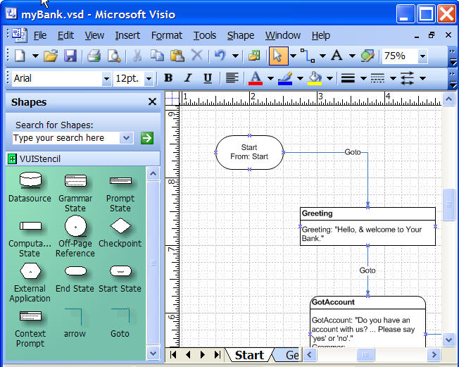

Figure 2 Visio Startup

If for some reason you don’t see the VUIStencil on the left side of the work area, choose File -> Shapes -> Open Stencil and select the file VUIStencil.vss that comes with this demo distribution.

When you select a shape from the stencil and drop it onto the work space, the shape pops up a window and asks you to fill in certain information, like prompt name, prompt text, etc.

The next section reviews the meaning of the stencil symbols.

VUIStencil.vss

Figure 3 The VUI Stencil Symbols

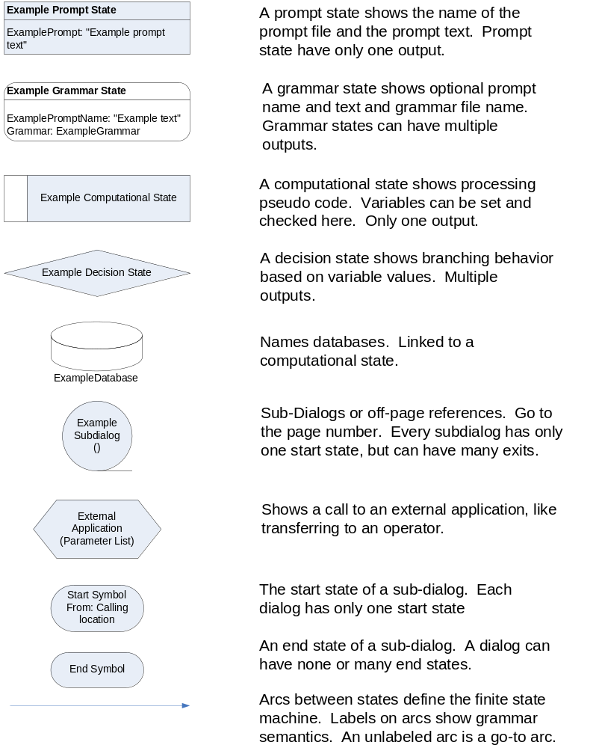

Developing a Call Flow

The best way to understand a call flow is to review an existing one. Take a few minutes to review myBank.vsd.

The Start tab shows the beginning of the application. The system first plays a greeting at a prompt state. The name of the state is ‘Greeting’ and the name of the prompt played at the state is also ‘Greeting’. The text of the prompt named ‘Greeting’ is ‘Hello and welcome to your bank.’

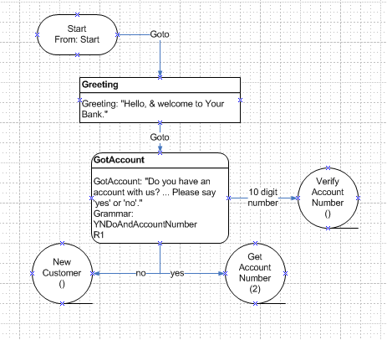

Figure 4 Start Tab of myBank.vsd

The next state is a grammar state named ‘GotAccount.’ It has a prompt named ‘GotAccount’ and a grammar named ‘YesNoDoAndAccountNumber.’ It asks the user if they have an account. The ‘…’ in the prompt indicates a pause. One useful convention is that every ‘.’ represents one second.

Under the grammar name is the text ‘R1’. When you select, drag and drop a grammar symbol onto the work area, Visio presents the following custom properties dialog:

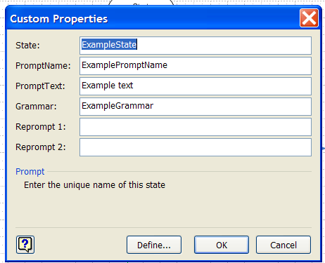
Figure 5 Initial Grammar Custom Properties

The filled in version of this for the state named GotAccount is as follows:

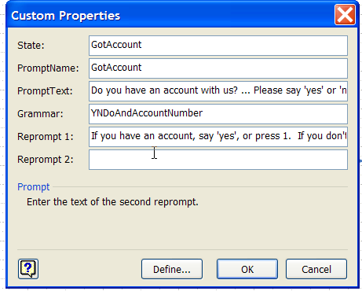
Figure 6 Filled-in Grammar Customer Properties

By convention, the initial prompt at this state will be in the file named GotAccount and is the text “Do you have an account with us…” If there is no response, or if the system doesn’t recognize what was said, the first reprompt, or R1, will contain the text “If you have an account, say ‘yes’ or press 1. If you…” The name of the file containing that text will be the PromptName at the state (GotAccount) suffixed with R1, or GotAccountR1. Reprompt 2 will be GotAccountR2, if that text is filled in (in this case it is not).

Referring again to the GotAccount grammar state in the myBank.vsd, the user can say ‘yes’ or ‘no’, as indicated by the arcs coming out of the grammar state. If they say ‘yes’ they’ll proceed to the sub-dialog named Get Account Number, which is on the second tab. If they say ‘no’, they’re taken to New Customer.

I haven’t put the page number in for that sub dialog yet, because it hasn’t been created. This shows how you can use sub-dialog references in a high-level functional flow. The user can also simply say or enter their account number at this state, and if they do, they’ll transit to ‘Verify Account Number.’

Figure 7 Start Tab

Now the labels on the arcs are, by convention, taken as the semantic meaning of the grammar and do not cover all the actual text. Note also that there are no details in the dialog design about what the names of the semantic tags are, or what the range of allowable values is.

Following the prescription that information should be stored in one place and changed in one place where it is needed, the tag names and range of values are stored in the grammar header files.
Exporting The Prompt List

To export the prompt list, from the Visio menu bar select Tools -> Macros -> Pass_to_Excel -> Export_Prompts, as follows:

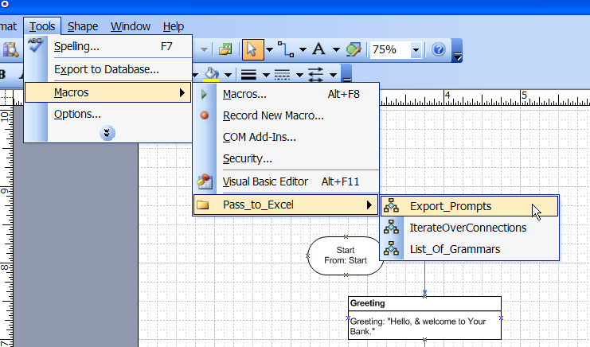
Figure 8 Exporting the Prompt List

The resulting dialog will ask you for an Excel file name. The file in the demo package is named ‘promptList.xls’ and looks something like this:

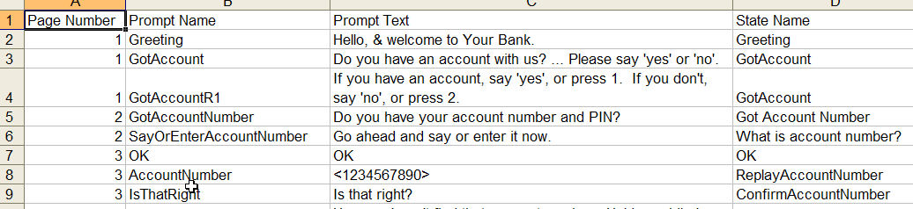
Figure 9 Exported Prompt List in Excel

The column headings show each prompt’s page number, name, text and the state name that the prompt was in. Notice lines 3 and 4 have prompts named GotAccount and GotAccountR1. R1 means ‘reprompt 1’ as discussed above.

Another design convention shown here is the use of the angle brackets ‘<’ and ‘>’. Text included in these indicates that it is a variable that can be instantiated in different ways in actual usage. In this case, there is the prompt AccountNumber containing the text <1234567890>. In an actual application, a large set of different account numbers would be accepted and played back to the caller for confirmation.

Comparing Prompt Lists

If there are duplicate prompt names or prompt text, they need to be discovered by sorting the Excel prompt list. That is, there is nothing in Visio or the extraction macros that stop you from entering duplicate names with the same or different text or vice-versa. So, after you export the prompts, use the Data -> Sort functions in Excel to discover duplicate prompts and/or prompt text.

You can compare two prompt lists and get the difference between them by using the utility ComparePromptLists.py, which takes as input two prompt lists and outputs a new file that shows the differences. To run this utility, double click on ComparePromptLists.py. Choose the inputs & output as shown below by selecting the buttons labeled with the ‘…’

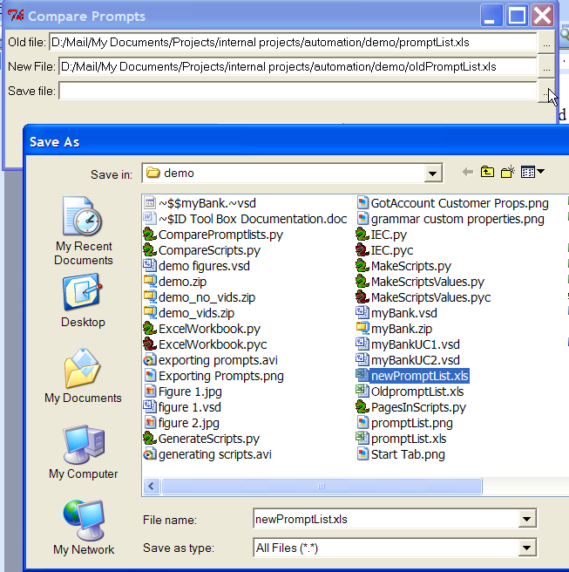
Figure 10 Comparing Prompt Lists

In this demo distribution, the inputs promptList.xls and oldPromptList.xls were compared and the output is newPromptList, which shows that there is one prompt with the same name but different text, then one prompt in each of the inputs which isn’t in the other, as shown below:

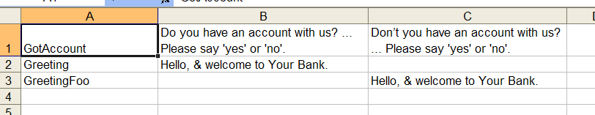
Figure 11 Output of Compared Prompt Lists

Exporting the Grammar List

Refer to Figure 8 for how to export the grammar list. Select Tools -> Macros -> Pass_to_excel -> list_of_grammars. The output looks like this:

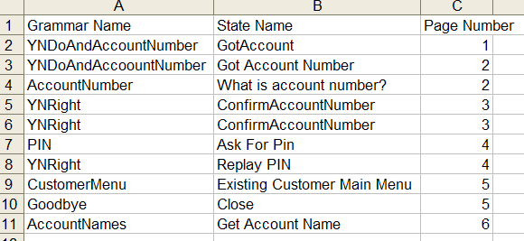
Figure 12 Exported Grammar List Excel File
Generating Use Cases with MakeScripts.py

When you have enough of a call flow to generate example dialog scripts, and you’ve exported and cleaned up the prompt list, you then create a set of Excel sheets containing source use cases. (Practically speaking, it is best to create one use case and run it through the program to make sure you’ve got it right before continuing on to the next one).

The source use cases actually don’t contain what the system says, but rather, they contain the file names of the system prompts, followed by the actual text of what the user says (or presses, or doesn’t say in the case of a time out). The advantage of creating source scripts is you can change the prompt text at will and regenerate final use cases automatically. If you change the dialog flow, however, such as adding a prompt state or changing its behavior, you’ll need to go and edit the use case. Typically, however, most changes are only prompt wording changes.

MakeScripts takes as input a list of source scripts and the prompt list, then outputs a single Excel spread sheet containing final scripts, where the prompt names in the source scripts are substituted by the corresponding prompt text.

Here’s the source scripts UseCase1.xls:

1 | Description - First time caller, knows account number and PIN, chooses checking account balance, gets results & hangs up.
System | Greeting GotAccount
User | Yes
System | GotAccountNumber
User | Yes
System | SayOrEnterAccountNumber
User | One two three four five
System | OK AccountNumber IsThatRight
User | Yes
System | Alright SayOrEnterPin
User | One two three four five
System | MainMenuLandmark CustomerMenu
User | Check balances
System | WhichAccount
User | Checking
System | CheckingHint
System | YourCheckingAccountBalanceIs Amount1
System | CloseOffer
User | Goodbye
System | ThankYouForCalling
Figure 13 Source Use Case 1

The file format is important for the program makeScripts.py. The upper left hand corner must contain an integer, and, when you run the program, it checks for unique integers. If you feed it two source scripts with the same use case number, the program will stop and complain. The program also looks for the first blank row as the indication that the use case if over, so, if you insert any blank rows, reading will stop there.

The most common mistake in creating source scripts is putting the wrong file name in the source script. You’ll discover this when you read the final output script and it still contains a filename, rather than comprehensible English text.

Here’s a screen shot of running MakeScripts.py:

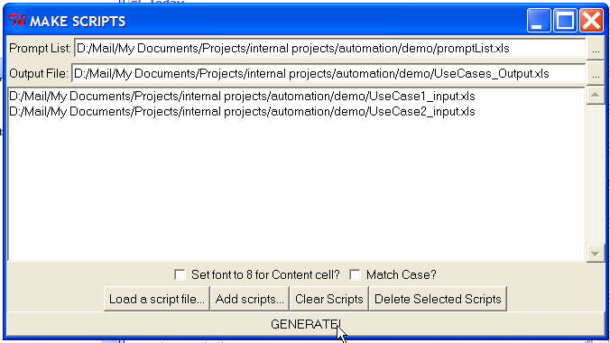
Figure 14 Running MakeScripts.py

To select the Prompt List and Output File from the file browser, select the buttons marked ‘…’ on the upper right. To add scripts from the browser, select the button labeled ‘Add scripts…’. Here I’ve added the two input use case source files. When you’re done, click on ‘Generate’.

The output file named UsesCases_Output.xls has three tabs. The first is a table of contents, which lists the script number (from the upper right hand corner of the source script) and the description of the case. The final two tabs contain the prompt text substituted for the file name. Here’s a screen shot of the first one:
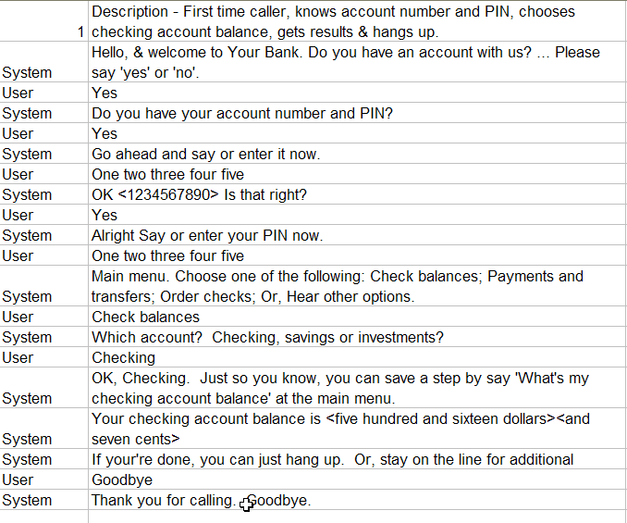
Figure 15 Use case 1 output.

After the first row, the system simply copies any row that doesn’t contain the word ‘System’ in the first column. If ‘System’ does appear in the first column, the program then goes through each white-space delimited token in the second column and searches for it in the prompt list. (So, be careful that you put spaces between prompt names in the source file).

If the token is found in the file names in the prompt list, the corresponding text is inserted. If the token is not found, it is copied to output. So, if you put text in the source file which is not in the list of prompt names, it will show up in the output. This is useful if you want to put something like ‘<system plays greeting icon>’ in the source script. However, if you add text which happens to match a prompt name, it will be substituted.

The reason the Tool Box doesn’t generate the user’s behavior automatically from the call flow is that in developing test cases, some data doesn’t reside in a user’s response, but actually resides in a third data structure, like a back-end database. Since this data needs to reside somewhere in order to generate test cases, but probably doesn’t belong in a call flow diagram, we’ve found it convenient to put it in the source use cases.

As you generate a large number of use cases, it becomes tedious to have to manually select them each time you want to re-generate the test package. To help with this and to help you manage sets of like use cases, you can enter in the names of the source use cases into a text file, and then load that file all at once into MakeScripts. In the demo distribution, there is a file named ‘useCaseList.txt’ that contains the following:

UseCase1_input.xls
UseCase2_input.xls

To all the source scripts at once, click on ‘load a script file’ and select ‘useCaseList.txt’ rather than clicking on ‘add scripts’ one by one.

Known Bugs

Don’t install the toolbox in a directory that has spaces in the name, for example, in your ‘My Documents” folder. The space in the name kills the file lookup in the generate scripts routine. Sorry.

